Fifteenth US/Europe Data Exchange Meeting

UK Met Office Telecommunications Status Report

Prepared By:

David Tinkler
Network Manager Tel: +44 (0)1344 856053
Room R302B Fax: +44(0)1344-856099
Met Office (UK), e-mail: dave.tinkler@metoffice.com
London Road, Bracknell,
Berkshire, RG12 2SZ.

1. Communication Links
Figure 1 UK Met Office Telecommunication links

Figure 1 shows some of the UK Met. Office (UKMO) telecommunications links. The message switches TROPICS and NETTLE send and receive data arriving over the links while the routers UKMO1 and UKMO6 provide the connections to the circuits or managed network services.
The TROPICS message switch is in the process of being replaced by a new message switch called FROST.
The Regional Meteorological Data Communications Network (RMDCN) is a managed IP network service provided by Equant for the WMO National Meteorological Services (NMSs) in WMO region VI. RMDCN also supports X25 encapsulated in IP.
UKMO has Frame Relay links with both British Telecom (Link to Australian BoM) and Worldcom (Link to NESDIS and CMC).

The following sections contain more detailed information on some of the links.

1.1 Links to NOAA
There are two links to NOAA, a Frame Relay link to NOAA-NESDIS and a 64KBits/sec leased line to the NOAA Office of Systems Operations (NOAA-OSO).

1.2.1 Links to NOAA-OSO
The link to NOAA-OSO is a 64Kbits/Sec leased line. There are two separate X25 data streams described in Table 1. The X25 data is encapsulated into IP and sent over the leased line using a router. The link utilisation is shown in Appendix A.

Speed Bits/sec | Protocol | NOAA-OSO System | UKMO | Data
64 K | X25 | NOAA-OSO Telecommunications Gateway | TROPICS | GTS
4.8K | X25 | NOAA-OSO Telecommunications Gateway | TROPICS | T4 Fax Products
Table 1 Details of the links between UKMO and NOAA-OSO
As part of the process of improving the GTS Main Trunk Network (MTN) a Frame Relay cloud is being established between the Regional Telecommunication Hubs (RTHs) in Bracknell, Melbourne, Tokyo and Washington. At the recent WMO expert team meeting on the Improved MTN (ET-IMTN) suppliers quotes were reviewed and a supplier selected.
This process will mean that the present leased line between Bracknell and Washington will be replaced with a Frame Relay connection.
1.2.2 Links to NOAA-NESDIS
The Frame Relay link to NOAA-NESDIS is used for the transfers of satellite sounding data. Details on the link is shown in Table 2, the utilisation is shown in Appendix A and the daily volumes of data is shown in Table 4.

Speed Kbits/sec | Protocol | NOAA-NESDIS System | UKMO | Data
512 Access/ 128 CIR from NESDIS | FTP | CEMSCS | NETLINK | Satellite Sounding data and products, see Table 4
512 Access/ 16 CIR to NESDIS | FTP | CEMSCS | NETLINK | ERS-2 Data
Table 2 Details of the links between UKMO and NOAA-NESDIS

The utilisation graph in Appendix A shows that the majority of the file transfers over the link take place at the access speed of the circuit rather than the Committed Information Rate (CIR).

1.2 Links to ECMWF
The 2MBits/Sec link to ECMWF is used to transmit files of data between UKMO and ECMWF using TCP/IP protocols. This data includes GTS Data, numerical modelling products and satellite data. UKMO users can also submit jobs to run on the ECMWF Cray and access data on ECMWF computer systems using their MARS and METVIEW software.

1.3 Links to RMDCN
The link from UKMO to the RMDCN network has an access speed of 384Kbits/Sec. Permanent Virtual Circuits (PVCs) are established across RMDCN to other National Meteorological Services (NMSs) in WMO region VI. The details of some of these are described in this section.

1.3.1 Links to Meteo-France
A PVC with a speed of 256Kbits/Sec out (UKMO to Meteo-France) and 128Kbits/Sec in (Meteo-France to UKMO) has been established.
The link is used for:
- Exchange of GTS and Radar data.
- Sending GOES and GMS satellite data to Lannion. This data is then sent from Lannion to METEOSAT for rebroadcast.
- Transmission of satellite sounding data such as the SSM/I and ATOVS data is sent to Meteo-France using this link.

1.3.2 Links to DWD
A PVC with a speed of 48Kbits/Sec in both directions has been established between the UKMO and DWD.

1.3.3 Other RMDCN Links
The UKMO has the following PVCs through RMDCN to other NMSs

National Meteorological Service | Protocol | PVC Speed Kbits/Sec | Status
Belgium (Brussels) | FTP | 16 Both ways | Operational
Denmark | TCP Sockets | 16 Both ways | Operational
DWD | FTP | 48 Both ways | Operational
Iceland (Reykjavik) | X25 Over IP | 8 Both ways | Operational
Ireland (Dublin) | FTP | 32 Both ways | Operational
Italy (Rome) | FTP | 16 Both ways | Operational
Meteo-France | FTP | 128 in  256 out | Operational
Moscow | FTP | 8 in/24 out | Operational
Netherlands (De Bilt) | TCP Sockets | 24 Both ways | Operational
Norway (Oslo) | TCP Sockets | 16 Both ways | Operational
Portugal | X25 Over IP | 16 Both ways | Operational
Spain | X25 Over IP | 32 Both ways | Under test
Table 3 Details of RMDCN Links to other NMSs in WMO Region VI

1.4 Other International Links
In an effort to gain routine, reliable access to global imagery from geostationary satellites, the Met. Office has implemented links as described briefly below. The approach has generally sought to identify mutual benefit from the exchange of satellite data and, hence, sharing of the costs involved.

1.4.1 Australian Met. Service
A Frame Relay link has been established between the UK Met. Office and the Australian Bureau of Meteorology (BoM) in Melbourne. The access speed is 128Kbits/Sec at each end and the CIR is 64Kbits/Sec to Melbourne and 32Kbits/Sec from Melbourne. The link is being used for the exchange of data in WMO bulletin format using TCP sockets with TROPICS, files of satellite imagery (METEOSAT from UK and GMS from Australia) and ATOVS level 1c data with NETLINK.

1.4.2 Canadian Met. Service
A 32 Kbits/Sec Frame Relay link has been established between the UK Met. Office and the Canadian Met. Service (CMC) in Dorval. It is being used for the exchange of data in WMO bulletin format with TROPICS and files of satellite data (METEOSAT from UK and GOES from Canada) with NETLINK.

2. Met. Office Communication Computer Systems

There are two computer systems at the Met. Office that are used to send data to customers. The TROPICS message switch handles all communications involving X25 protocols and WMO messages, it also has the ability to send WMO messages using FTP or TCP/IP sockets. The NETLINK system has the ability to send files using FTP.
The functions of TROPICS are being replaced by the FROST; a UNIX based system. The FROST system went operational on the 22nd May 2002; it is now planned to migrate the TROPICS services over to FROST in the next few months. As part of this migration the X25 data transfers to NOAA-OSO will be replaced by TCP sockets as shown in Figure 2.
In general FROST is used for the transfer of low volume data, typically from 100 Bytes to 50 Kbytes, where high speed data switching is important. NETLINK is used for the distribution of higher volume data at slower data switching speeds.

Figure 2 Met Office Telecommunication Links after FROST Migration

2.1 NETLINK
The NETLINK computer system is responsible for the operational transfer of files of data between computers on the Met. Office Central Data Network (CDN) and computers on external networks. It consists of two identical Compaq Alpha Computers running OpenVMS, the main system is called NETTLE and its backup is called TEAZLE.
The NETTLE system is a Compaq Alpha 1200/533 with 256 Mbytes of memory running OpenVMS V7.2 operating system. Currently the system is switching 10,000 files per day, which is about 6.5 Gbytes of data.

Table 4 shows the data and its associated volumes sent to NETTLE over the Frame Relay link at present.
Requirements Description | Daily Data Volume (MBytes)
ATOVS Level 1B data | 283.1
SSM/I Brightness temperatures | 231.0
Level 1B TOVS Data | 219.3
QuikScat Scatterometer data | 180.0
Ice/snow gridded field derived from SSM/I data | 80.0
AVHRR Products on a HIRS Grid, derived as part of the NESDIS ATOVS Processing | 62.0
AVHRR 100km and 50Km SSTs | 7.9
AVHRR Mapped Global Area Composites | 6.3
GOES cloud-tracked VIS/IR/WV Winds | 2.6
Ozone Retrieved profiles and/or total column from SBUV on NOAA | 1.3
Total from NESDIS to UKMO | 1073.5
Table 4 Data Volumes from NESDIS to UKMO

Table 6 shows the anticipated increase in data volumes over the next year based on the data in the present European requirements list . The expected increase in link capacity required to be able to accommodate that data is also shown. The present link runs at the frame relay access speed but this speed could drop to the committed information rate (CIR) if the suppliers network becomes congested. It is proposed that the link is operated at a CIR similar to the average daily data rate with an access speed four times that value. As long at the network continues to operate at the access speed there should be sufficient bandwidth and if the network becomes congested and the data rate drops we can pay to increase the CIR (up to 80% of the access speed). With present predicted data volumes this means we would increase the link speed early 2003 to accommodate the expected future data increases.

A document containing options for backing up the data on the NESDIS link was prepared for discussion. The option selected was to routinely copy high priority data (defined as data crucial to operations) from the CEMSCS system at NESDIS to the NOAA-OSO FTP Server. In the event of a problem with the NESDIS link UKMO would pull the data from this server over the NOAA-OSO GTS link and then pass it to the NETLINK system for processing.
The European Met Services provided information on the priority for the data sets on the dedicated link shown in Table 5. From the information provided it was decided to proceed with backing up the ATOVS level 1B data sets. Access to files on the NOAA-OSO server from Bracknell over the NOAA-OSO GTS link has been successfully tested. It is hoped to set up the routine transfer of the ATOVS level 1b data to the NOAA-OSO server shortly.

Data Set | UKMO | ECMWF | Meteo-France
ATOVS Level 1b | 1 | 1 | 1
AVHRR 100/50 km SST | 3 | 4 | 3
AVHRR Mapped Images | 2 | 4 | 3
AVHRR products for HIRS | 3 | 3 | 3
GOES AMVs | 1 | 1 | 3
SSM/I Sea Ice | 4 | 1 | 4
TOVS Level 1B | 4 | 1 | 4
SBUV Ozone | 3 | 2 | 3
Quikscatt | 1 | 1 | 2
SSM/I BTs | 1 | 1 | 2
Table 5 Priorities for Data Sets on Bracknell NESDIS dedicated link

Categories are:
- High Priority (crucial for operations)
- Medium Priority (operational or pre-operational use but not critical
- Low Priority (research datasets)
- No Requirements

Date | Data Volume (Mbytes) | Average Link Speed (Kbits/Sec) | Link CIR (Kbits/Sec) | Link Access Speed (Kbits/Sec) | Additional Data Requirement
01/07/2000 | 650.0 | 60.2 | 64 | 256
01/10/2000 | 862.3 | 79.8 | 64 | 256 | NOAA-L
01/01/2001 | 862.3 | 79.8 | 64 | 256
01/04/2001 | 862.3 | 79.8 | 64 | 256
01/07/2001 | 1043.5 | 99.4 | 128 | 512 | Quickscatt NOAA-L AVHRR
01/10/2001 | 1073.5 | 99.4 | 128 | 512 | NOAA-L AVHRR
01/01/2002 | 1073.5 | 99.4 | 128 | 512
01/04/2002 | 1073.5 | 99.4 | 128 | 512
01/07/2002 | 1473.3 | 121.8 | 128 | 512 | NOAA-M AMSU & AVHRR
01/10/2002 | 1515.7 | 140.3 | 128 | 512 | SSM/IS, AIRS and AMSU on AQUA
01/01/2003 | 2095.7 | 194.0 | 256 | 1024 | SEAWINDS on ADEOS & WINDSAT
Table 6 Data Volumes on the NESDIS Frame Relay Link.

2.2 FROST
The new Met Office FROST system is based upon a pair of HP L3000 servers running HP-UX Operating System software configured to run as a main system and a hot standby. There is a separate HP A500 Test & Development server.
A dedicated gigabit Ethernet link between the systems is used for management traffic and data synchronisation.
Application software is based upon the Messir-Comm message switching package for WMO message switching supporting FTP and TCP sockets. This is integrated with Nexor Mailer/Mixer software for general message switching using X.400 and SMTP. Legacy X.25 communications is supported by a pair of CISCO 3640 routers hot-switchable between servers. Operations and management of the system is performed using client software running on standard desktop PCs augmented by integration of the system with existing Met Office Tivoli and OpenView management platforms.
Part of the migration plan from TROPICS to FROST is that when the GTS links to Washington are transferred the data will be transferred using TCP sockets rather than X25.

The data volumes between Washington and Bracknell are shown in Table 7, Table 8 & Table 9. They show a large increase in GRIB data transferred, this is due to the addition of GRIB data exchange from model runs at 06Z and 18Z in the last year. The graph of link utilisation in Appendix A shows there are now daily four peaks which is the GRIB data exchange.

Date | Washington to Bracknell |  | Bracknell to Washington
 | Data (Mb) | Msgs | Data (Mb) | Msgs
April 1996 | 9.2 | 14256 | 9.1 | 13651
May 1997 | 9.6 | 15535 | 10.4 | 14662
May 1998 | 13.2 | 16524 | 11.0 | 15884
May 1999 | 17.5 | 18036 | 12.4 | 19199
June 2000 | 21.3 | 22123 | 14.2 | 24359
April 2001 | 32.7 | 23011 | 16.4 | 28925
June 2002 | 41 | 31354 | 18 | 32247
Table 7 GTS Link Alpha-Numeric Channel

Date | Washington to Bracknell |  | Bracknell to Washington
 | Data (Mb) | Msgs | Data (Mb) | Msgs
April 1996 | 72.8 | 19455 | 75.9 | 23463
May 1997 | 75.6 | 19220 | 77.3 | 23007
May 1998 | 80.1 | 19932 | 66.5 | 16259
May 1999 | 78.7 | 19876 | 68.7 | 16343
June 2000 | 83.1 | 20389 | 75.3 | 17763
April 2001 | 86.1 | 20740 | 86.6 | 20006
June 2002 | 163 | 36186 | 119 | 24961
Table 8 GTS Link GRIB Channel

Date | Washington to Bracknell |  | Bracknell to Washington
 | Data (Mb) | Msgs | Data (Mb) | Msgs
April 2001 | 5.4 | 59 | 5.4 | 60
June 2002 | 3 | 33 | 6 | 68
Table 9 GTS Link T4 Channel

3 Met Office Relocation

The Met Office is moving to the Exeter in the South West of the UK, around 200 miles from the current location in Bracknell. The new buildings are currently being constructed.
At the new site there will be two separate IT Halls. Diversely routed communication ducts to each hall will enable highly resilient communication circuits to be available.
The present timetable is that the new IT halls will be available by April 2003 at which point the migration of computer systems and circuits begins. Most people will be moving between August and November 2003 with the present building in Bracknell closing in March 2004.
For the transition period a high speed resilient communication circuit will be in place between Bracknell and Exeter to ensure systems at each end can intercommunicate.
It is planned to move the message switches from Bracknell to Exeter first and then migrate the communication links afterwards. It is expected that most links will have migrated by the end of 2003.
For operational systems with main and backup systems at Bracknell the transition plan is to provide additional main and backup systems at Exeter to ensure that system availability is maintained during transition.

Appendix A Utilisation of UK Met. Office Links to NOAA

A1 Links to NOAA-OSO

A1.1 Utilisation of GTS Link between UKMO and NOAA-OSO
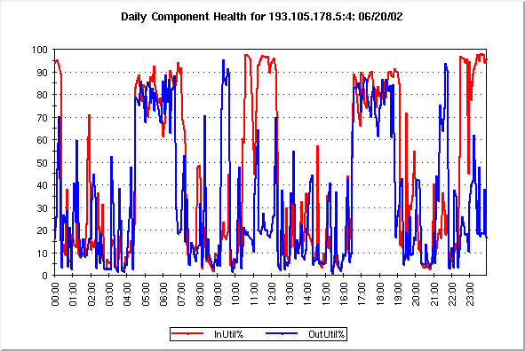

Utilisation of the Bracknell Washington Link June 2002
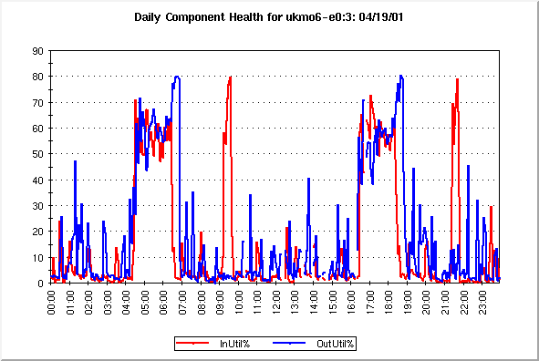
Utilisation of the Bracknell Washington Link April 2002
The graph shows the input and output utilisation of the GTS link to NOAA-OSO relative to the bandwidth of 64Kbits/Sec.

A2 Frame Relay Link to NOAA-NESDIS

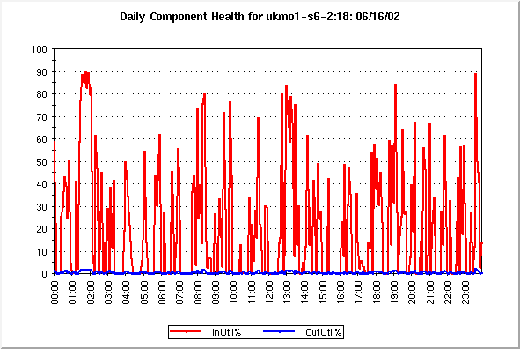

The graph shows the input and output utilisation of the Frame Relay link to NESDIS relative to a bandwidth of 512Kbits/Sec which is the access speed of the frame relay circuit.

